

**By**

**Sunil Raj Thota  
ALY6030 - Data Warehousing and SQL**

**Class Name: Fall 2021 CPS Quarter**

**Class Number: 202215**

**CRN: 70526**

**Week 5 Assignment 5**

**thota.su@northeastern.edu**

**Summary:**

Learning Microsoft SQL Server 2019 is a LinkedIn Learning course by Adam Wilbert. He talks over the most significant features of working with SQL Server 2019 in this course, giving novice users an overview of how the server works. He leads us through creating tables, defining associations, and writing and running queries with Transact-SQL commands in the main working environment, SQL Server Management Studio. By the end of this course, I have learned everything that I need to know about creating my database. It is easy to start and learn operating with an enterprise-level database management system.

The list consists of the course's sections:

Introduction

1. Get Started with SQL Server
2. Work with the Server
3. SQL Server Management Studio
4. Write Transact-SQL Commands

Conclusion

**Content:**

**Introduction:**

This course will rapidly get you up to speed on all you need to know about SQL Server so you can get started collecting, storing, and retrieving data. Adam touched on installing SQL Server 2019 on our PC using the free Developer version, starting and stopping the server, and creating new databases using the Management Studio graphical interface. We'll also look at the importance of data tables and table connections in data management, as well as how to add rows of data to tables using Transact-SQL queries.

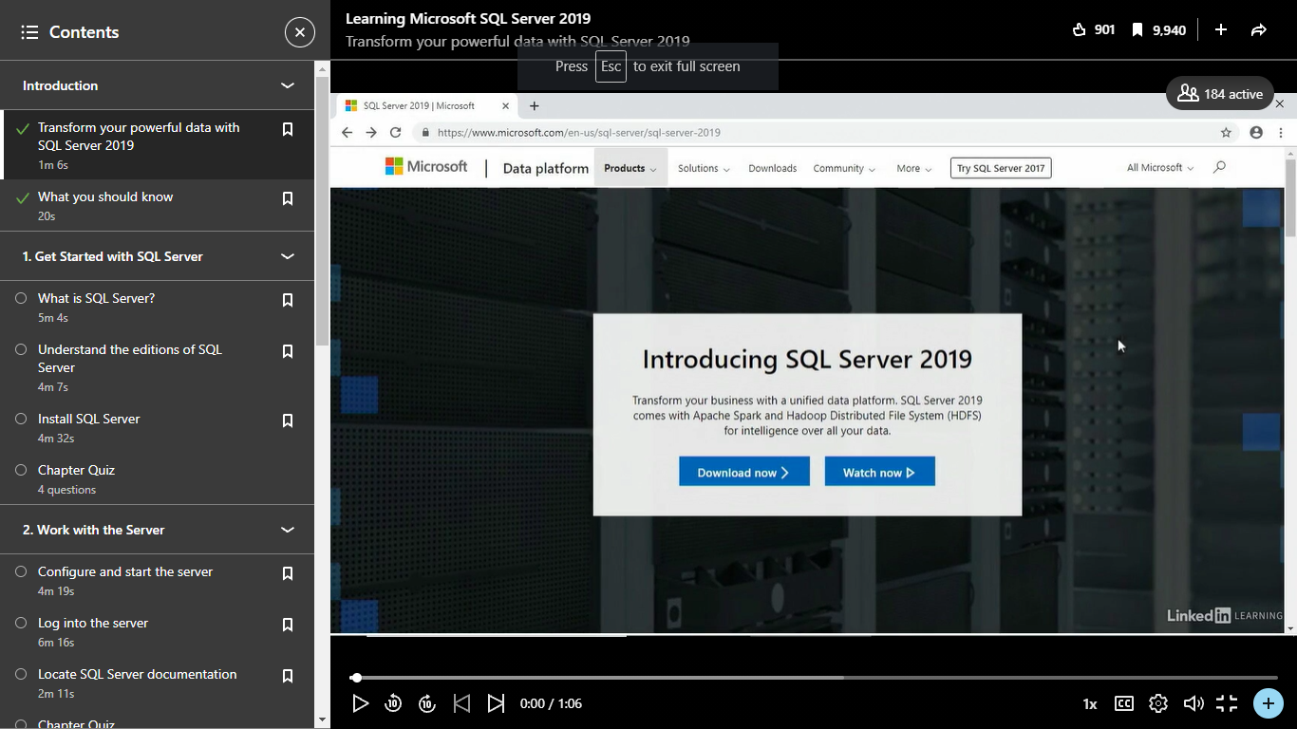

1. **Get Started with SQL Server**

A relational database management system, or RDBMS, is SQL Server 2019. All of the processes connected with storing and retrieving data from a database are handled by a database engine. On a single computer, many instances of SQL Server can be installed, allowing administrators to limit access and manage resources. Specific permissions to access data within databases are granted to users at this level. There are various versions like Express, Developer, Enterprise, and Standard based on the use cases.

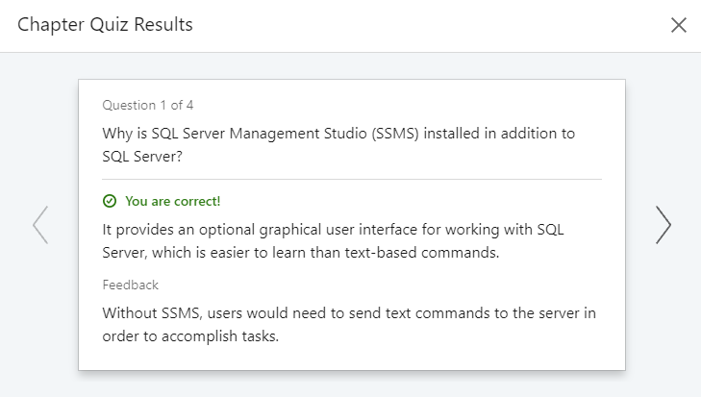

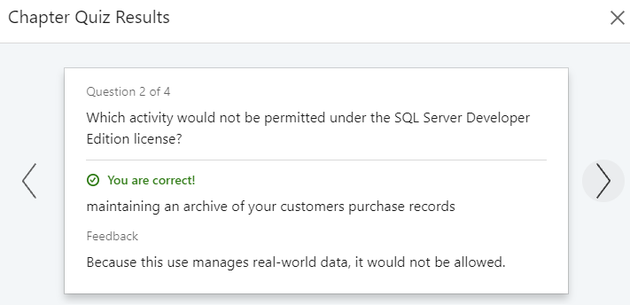

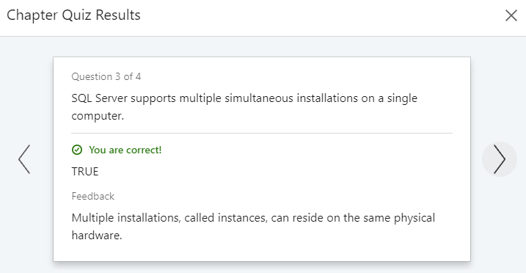

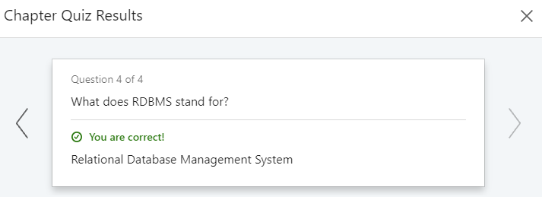

SQL Server comes with its command-line interface. Transact-SQL scripts will be used by the majority of system and database administrators to issue commands. The installation steps of SQL Server were delved deeper.

1. **Work with the Server**

We'll need to use a tool called Configuration Manager to manage the settings and stop and start the server. The server, a browser, and an agent are the three services that we have. The documentation for SQL Server 2019 may be found at this URL. Client Protocols and Aliases can be configured within the Configuration Manager if necessary. We'll use an application called SQL Server Management Studio to work within the server.

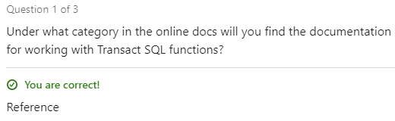

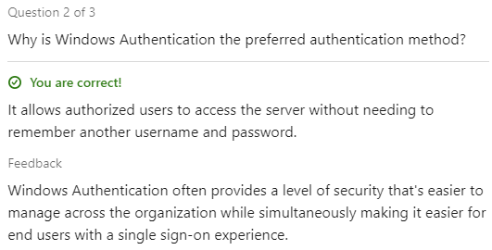

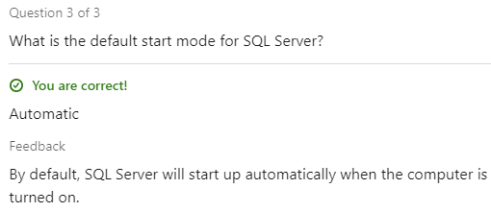

1. **SQL Server Management Studio**

Management Studio or SSMS will give us the main interface that we're going to use when we're working with SQL Server. Some of these toolbars will activate automatically as you perform tasks within Management Studio. This is another instance of the query editor window. You'll notice that our SQL editor toolbar has once again returned to the top of the screen. The other common thing that you'll find yourself needing to do a lot in SQL Server Management Studio is to refresh the contents that are being displayed over in the object explorer. Next, I want to make sure that SQL Server knows that this column will store the primary key data for the table.

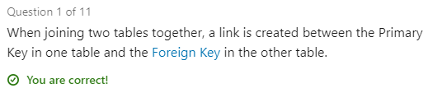

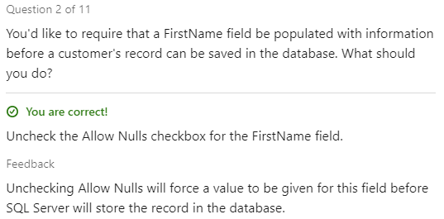

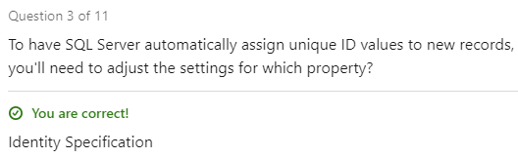

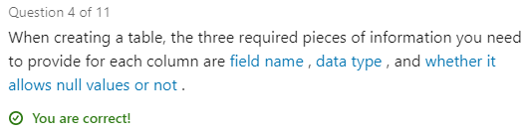

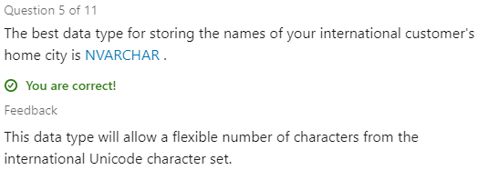

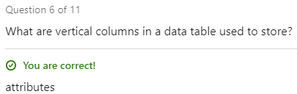

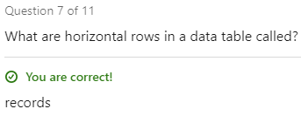

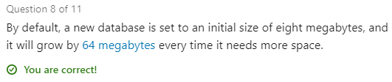

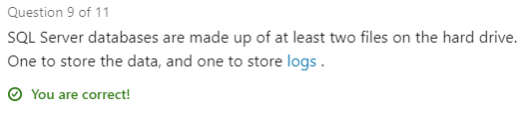

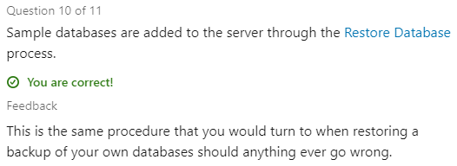

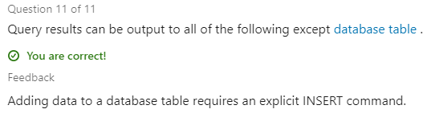

1. **Write Transact-SQL Commands**

Just separate the name of each column with a comma. Upon the SQL editor toolbar is a drop-down menu, where we can specify the target database for this query. Because we didn't specify the limit the results to just the top 1000 records, we're going to get back a row in our results, for each record in the database. Instead of viewing all 73,000 orders, what if I just wanted to see the orders placed by the customer with the ID of 578? These are the 108 orders that were placed by the customer with the ID of 578. The Select clause defines the columns that you'd like to see, the From clause identifies the table where the data is, the Where clause will allow you to supply any filtering criteria, and the Order By clause will allow you to sort the records to suit your needs. Using what you've seen here, see if you can write a query against the Sales.

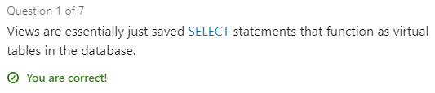

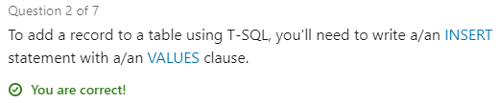

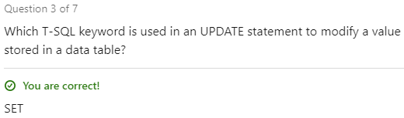

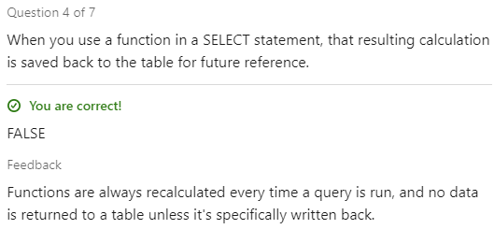

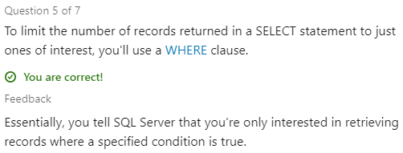

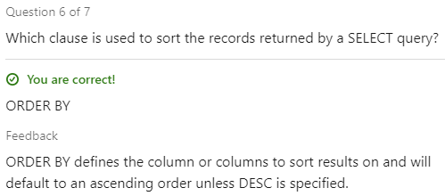

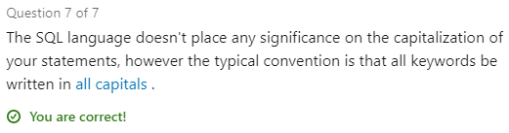

Using a query, we can update the data that's stored in our data tables. For example, we could look at Sales.OrderLines and see a total amount due for each order line. Views act just like tables do in our database. They're not storing any data; they're simply piecing together existing data tables.

**Code: Create a SELECT statement**

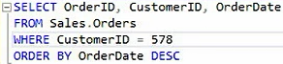

**Result:**

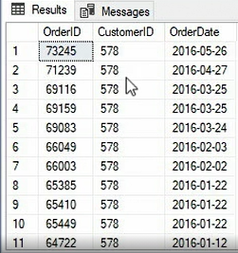

**Code: Use functions to calculate values**

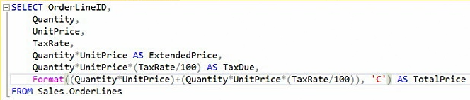

**Result:**

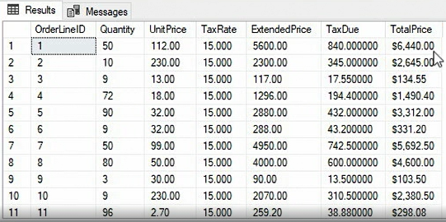

**Code: Write an UPDATE statement**



**Result:**



In this example, we're going to add another guest to the Landon Hotel database. Most data-entry tasks in SQL Server will be accomplished through the Transact-SQL commands. We'll start our query with INSERT INTO. Then we'll supply the name of the table that we're inserting records into. That'll be dbo. So, we're going to insert some records into dbo.

To do this, I need to specify the first name and the last name columns. When I'm done typing in the value pairs, I'll press the Execute button to run the query. Selecting data with Transact-SQL works similarly to the other queries that we've seen. You'll specify where the inserted data is going and what the values are. Remember that each group is just a comma-separated list and that the column names and values need to be in the same order.

**Code: Add data with an INSERT statement**



**Result:**

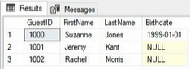

**Code: Create a view of the data**



**Result:**

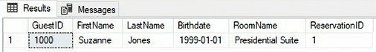

**Conclusion:**

This certification covers the fundamentals of Microsoft SQL Server 2019, including how to work with databases. Many of the fundamental principles were covered, but there is always more to learn. I am also planning to do a recommended four-part series on database foundations for a deeper dig into how to design databases in SQL Server with a focus on the theory behind why we build databases the way we do. This series begins with some fundamental principles, then moves on to data creation and manipulation, data storage, and finally, certain administration topics to be aware of.

**References:**

[1] Adam Wilbert. (April 18, 2019). Learning Microsoft SQL Server 2019. *LinkedIn Learning*. Retrieved from https://www.linkedin.com/learning/learning-microsoft-sql-server-2019

**Certification:**

